A Renewable Energy Smart Metering System Using LoRa Network

D. Manoj Kumar Department of Electronics and Communication Engineering
SRM Institute of Science and Technology, Ramapuram Campus Chennai, India
manojkud1@srmist.edu.in
Sirimaram Mahidhar Department of Electronics and Communication Engineering
SRM Institute of Science and Technology, Ramapuram Campus Chennai, India
sm6150@srmist.edu.in
Kudithipudi Dhanveer Department of Electronics and Communication Engineering
SRM Institute of Science and Technology, Ramapuram Campus Chennai, India
kd5832@srmist.edu.in
Vaddepally Punith Kumar Department of Electronics and Communication Engineering
SRM Institute of Science and Technology, Ramapuram Campus Chennai, India
vp5822@srmist.edu.in

Abstract— To meet the objectives of the Paris Climate Conference (COP21), several power generation plants that used to rely on fossil fuels have been converted to renewable energy sources globally. However, renewable energy sources can be difficult to manage on a fixed schedule due to unpredictable environmental factors like weather. To address this challenge, it is possible to optimize power generation by gathering, analyzing, and utilizing real-time data on continuous power generation. This data can also be utilized for efficient maintenance and future power generation forecasting, resulting in increased grid reliability and flexibility. This study proposes the use of open IoT hardware and software platforms to create an effective energy monitoring system and construct economically feasible systems that are both reliable and flexible. Many sensors are used to monitor a renewable energy-producing plant. The energy produced is one of the main characteristics that need to be tracked in this case; it may be estimated by measuring current and voltage. It is simple to compute energy produced using current and voltage values. Low-cost solutions are used to implement LoRa, which supports low-power long-distance networks. Smart metering systems have revolutionized the energy industry by providing more accurate and real-time data on energy consumption. In this Article, propose a Renewable energy smart metering system using a LoRa network. The proposed system uses LoRa technology, which provides a long-range and low-power wireless communication solution and is well-suited for the requirements of smart metering applications. The system consists of a LoRa gateway, multiple LoRa nodes, and a cloud-based server for data management and analysis. The LoRa nodes are installed at each household or building to measure and collect energy consumption data, and the gateway acts as a bridge between the nodes and the cloud server.
Keywords: Internet of Things, Arduino UNO, nodemcu, LoRa, Pv Panel.

- INTRODUCTION

The energy demand is increasing day by day, and it is becoming more critical to accurately measure and monitor energy consumption. Smart metering systems have emerged as a promising solution to address this issue by providing accurate and real-time data on energy consumption. Traditional smart metering systems use wired or wireless communication technologies such as Wi-Fi to transmit data from the meter to the utility provider. However, these systems have limitations in terms of communication range and energy efficiency. The Internet of Things (IoT) is a concept that involves connecting intelligent devices to a network to perform various tasks. The primary objective of IoT is to improve the quality of human life and experience by making everyday activities more efficient and convenient. By leveraging sensors, software, and connectivity, IoT devices can collect and exchange data with other devices and humans, enabling them to operate autonomously and in real time. This technology has the potential to transform various aspects of daily life, including home automation, healthcare, energy consumption, and transportation systems, among others. The ultimate goal of IoT is to create a more connected and intelligent world that is better equipped to meet the needs and preferences of individuals and communities. [1]. Remote energy use monitoring is made possible by smart meters, which is essential for both users and the operator. This is one of the potential uses of IoT. With the internet, people and other sensing devices can engage or communicate with these objects. Smart metering consists of digital and electrical technologies communicating and transmitting information from one device to another [2]. The smart meter has been introduced as an alternative to conventional electricity meters for the general public. Traditional power meters require manual inspection by metering workers from energy delivery companies. On the other hand, smart meters enabled by the Internet of Things (IoT) offer users automated and precise meter readings, along with the capability to monitor and regulate their energy consumption remotely. This technology has the potential to enhance user involvement in energy conservation, as well as encourage significant and affordable customer involvement in the utility industry. Additionally, smart meters can support various objectives aimed at reducing the impact of climate change and ensuring energy security [3].

- LITERATURE SURVEY

Unal Fatih, et al. proposed a cutting-edge Big Data-driven solution using parallel computing, deep learning, and machine learning methods. Acquired reliable statistical features has been introduced to identify cyber threats based on FDIs at the distribution level. [4]. Kane Luke, et al. propose the Home Area Network (HAN) architecture is designed to utilize the LoRa 2.4 GHz technology, which is a dependable and highly adaptable transmission technology. The HAN also incorporates a secure authentication method based on ChaCha20-Poly1305 Authenticated Encryption with Associated Data (AEAD). This ensures the safety and privacy of user data transmitted over the network. [5]. Liu Fangxing, et al. proposed identifying faulty smart meters, modelling the low-voltage energy system, and estimating meter inaccuracy [6]. Zhuoqun Xia, et al. proposed a more secure session key management solution for the LoRa-based meter-reading system [7]. Jin Kim Young, et al. proposed the identification of non-technical loss (NTL) such as meter tampering, bypassing, or malfunctioning can be achieved through the utilization of an intermediate monitor meter (IMM) and the concept of unit networks (UNs) for power distribution network modeling. [8]. Mihai Sanduleac, et al. proposed a framework for information extraction from SM data with high reporting rates. The proposed technique has the potential to improve the monitoring of distribution power grids as it operates at the system level, is cost-effective, and maintains the privacy of the users. The concept of unit networks and an intermediate monitor meter-based power distribution network model can be utilized to detect non-technical loss caused by meter tampering, malfunction, or bypassing of the unit networks. This method involves the use of a monitoring system that can identify discrepancies between the actual power usage and the recorded data by the meter. By analyzing the data from the intermediate monitor meter, it is possible to identify instances of non-technical loss and take appropriate measures to address them. This approach can be effective in detecting and preventing electricity theft, which can significantly impact the revenue of power distribution companies and lead to higher energy costs for consumers. Overall, the unit networks and intermediate monitor meter-based model can provide a useful tool for improving the efficiency and accuracy of power distribution networks. [9]. Jose Gallardo Luis, et al. proposed a machine learning clustering approach-based optimal placement of DAPs for AMI in residential grids. To establish sub-networks, network partitioning is implemented. Given optimization constraints, graph algorithms then produce a deployment topology. [10].

- METHODOLOGY

This Article introduces a monitoring system for renewable energy production units. Several nodes of the system are connected using LoRa communication. The generated power is measured by a current and voltage sensor, and the data is transmitted to a distant node for further analysis. The Internet of Things (IoT) enables remote access to the data. The project is being developed using the Arduino platform, which is an open-source platform and financially feasible. Any type of embedded controller can be used for this project, and the Arduino platform is preferred due to its practicality. The Article proposes a renewable energy smart metering system utilizing LoRa network technology. LoRa (Long Range) is a wireless communication technology that employs a low-power, wide-area network (LPWAN) to enable long-range communication with a low data rate. The system is designed to minimize energy consumption while maintaining reliable communication over long distances. The system comprises a LoRa gateway, multiple LoRa nodes, and a cloud-based server for data management and analysis.

- BLOCK DIAGRAM

Arduino Uno is used in the sensor node. The analogue interface on Arduino Uno is used to connect both sensors (ADC). A serial Interface is used to link LoRa devices. The data node uses the NodeMCU, which includes built-in Wi-Fi, to connect this node to the cloud. Using LoRa, this NodeMCU is linked to a receiver.

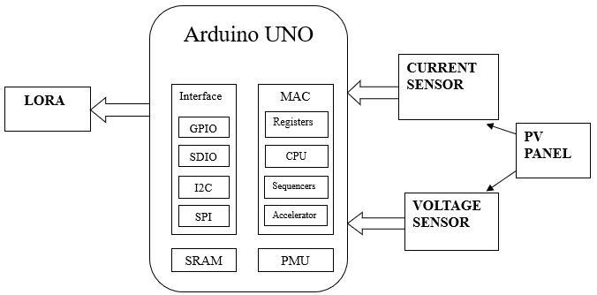

Fig 1.1 TRANSMITTER (Tx) (SENSOR NODE)

In the Transmitter node, Electricity comes from the PV Panel. Voltage and Current sensors sense how much amount of electricity is stored in the PV Panel. The sensor sends the signal to the LoRa TX through Arduino in Fig 1.1. In the Receiver node, LoRa RX receives the signal from the LoRa TX. LoRa RX sends the signal to the IOT Platform through Arduino in Fig 1.2.

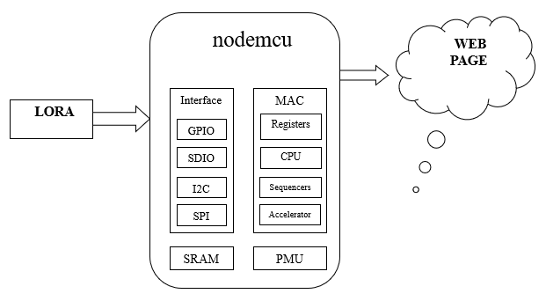

Fig 1.2 RECEIVER (Rx) (DATA NODE)

- RESULTS

The voltage and current values of the transmitter sensor node are shown in Fig. 2. The information will be transmitted from the transmitter across the LoRa network to the receiver. The sensor and data node outputs are illustrated in Figures 3 and 4. The results of the proposed system are shown in Fig. 5.

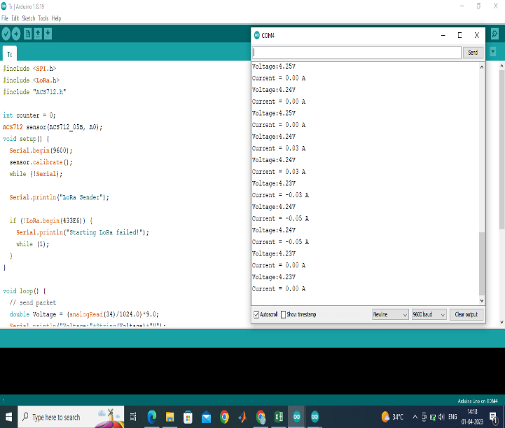

Fig.2 TRANSMITTER (SENSOR NODE)

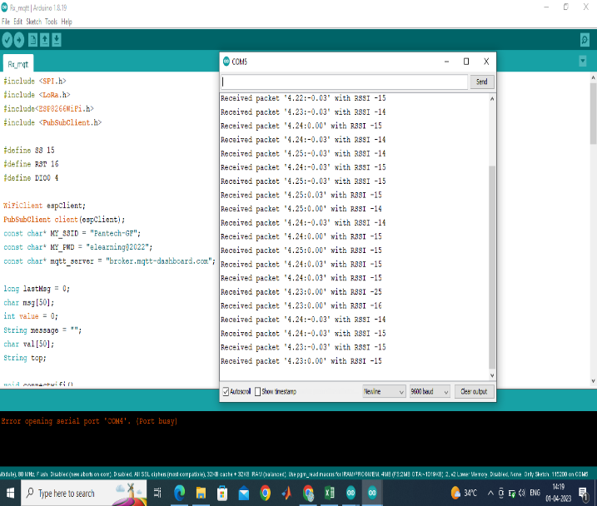

Fig.3 RECEIVER (Data Node)

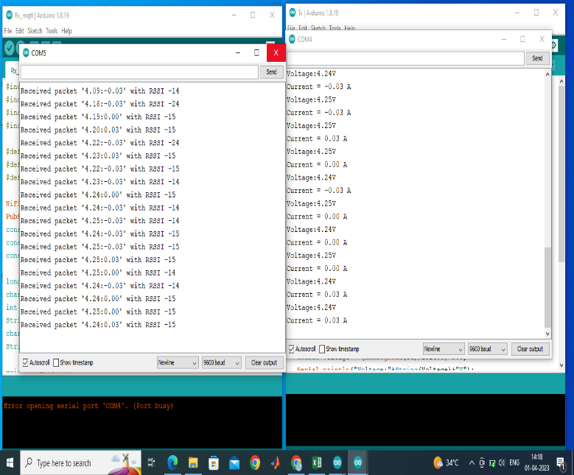

Fig.4 Output

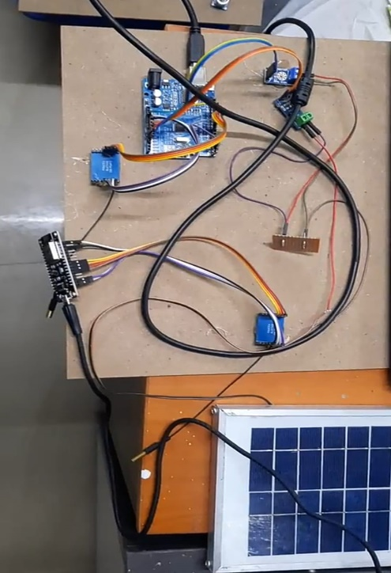

Fig.5 Circuit

- CONCLUSION

In conclusion, this article presents the development of a renewable energy smart metering system based on the LoRa network. The system proposed in this study aims to offer instantaneous data collection and monitoring of energy usage in both residential and commercial buildings. The system employs LoRaWAN technology, which provides long-range and low-power capabilities, making it ideal for smart metering applications. The system's hardware and software architecture were described in detail, including the design of the LoRa gateway and the smart metering nodes. The experimental results demonstrated the system's effectiveness in terms of energy efficiency and data accuracy. The proposed system achieved a high level of energy efficiency by reducing the number of data transmissions and optimizing the transmission frequency. Moreover, the proposed system's user interface allows consumers to monitor their energy consumption in real-time and make informed decisions to reduce their energy consumption, thereby contributing to a sustainable environment. Additionally, the system's scalability makes it suitable for deployment in various settings, including rural areas and smart cities. Overall, the proposed energy-efficient smart metering system based on the LoRa network presents an effective and sustainable solution for managing energy consumption. The system's efficiency, accuracy, and user-friendliness make it a viable solution for energy management in residential and commercial buildings.

- FUTURE ENHANCEMENT

In future solar power will account for a bigger share of the global generation of power. A rated overall energy should be Solar platform manufactured. More Sensors has to be interfaced in this proposed system to make this system more efficient and to increase the power production.

REFERENCES

- Kebotogetse, Otisitswe, Ravi Samikannu, and Abid Yahya. "A concealed based approach for secure transmission in advanced metering infrastructure." IEEE Access 10 (2022): 84809-84817.
- Kumari, Preti, et al. "An energy efficient smart metering system using edge computing in LoRa network." IEEE Transactions on Sustainable Computing 7.4 (2021): 786-798.
- Alkawsi, Gamal Abdulnaser, and Yahia Baashar. "An empirical study of the acceptance of IoT-based smart meter in Malaysia: The effect of electricity-saving knowledge and environmental awareness." IEEE Access 8 (2020): 42794-42804.
- Unal, Fatih, et al. "Big data-driven detection of false data injection attacks in smart meters." IEEE Access 9 (2021): 144313-144326.
- Kane, Luke, et al. "Network Architecture and Authentication Scheme for LoRa 2.4 GHz Smart Homes." IEEE Access 10 (2022): 93212-93230.
- Liu, Fangxing, Chengbin Liang, and Qing He. "Remote malfunctional smart meter detection in edge computing environment." IEEE Access 8 (2020): 67436-67443.
- Xia, Zhuoqun, et al. "Secure session key management scheme for meter-reading system based on LoRa technology." IEEE Access 6 (2018): 75015-75024.
- Kim, Jin Young, et al. "Detection for non-technical loss by smart energy theft with intermediate monitor meter in smart grid." IEEE Access 7 (2019): 129043-129053.
- Sănduleac, Mihai, et al. "High reporting rate smart metering data for enhanced grid monitoring and services for energy communities." IEEE Transactions on Industrial Informatics 18.6 (2021): 4039-4048.
- Gallardo, José Luis, Mohamed A. Ahmed, and Nicolás Jara. "Clustering algorithm-based network planning for advanced metering infrastructure in smart grid." IEEE Access 9 (2021): 48992-49006.

